Variables
Colour Mixer
Variables are like labelled boxes that have a label (name of the variable) so that we know what is stored inside (value of the variable). Variables store a value & the value can change.
Example: a computer game has a variable – score, to track number of points won in a game
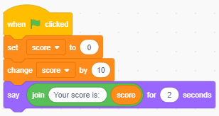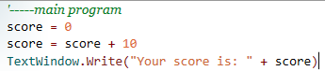
Mix Red, Green and Blue color proportions to create your own unique color!
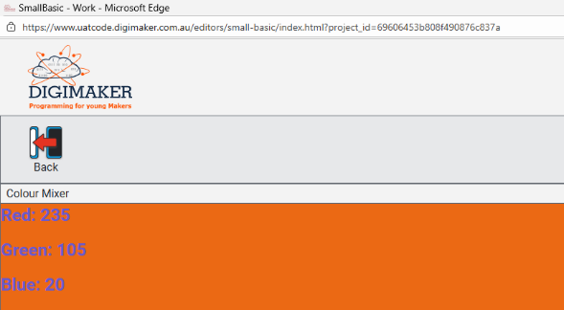
Get Ready
- Get project: Click on “Load Starter Code” and then click save – no starter code
Add Your Code
- Randomly generate numbers between 0 - 255 and store in three variables
r = Math.GetRandomNumber(255)
g = Math.GetRandomNumber(255)
b = Math.GetRandomNumber(255)

GraphicsWindow.Title = "Colour Mixer"
GraphicsWindow.FontSize = 25
GraphicsWindow.BackgroundColor = GraphicsWindow.GetColorFromRGB(r,g,b)
GraphicsWindow.DrawText(0, 0, "Red: " + r)
GraphicsWindow.DrawText(0, 50, "Green: " + g)
GraphicsWindow.DrawText(0, 100, "Blue: " + b)
Try It Out!
- Click on Save. Click on Run. What color did you make?
Challenge!
Text colour
Change text colour to white and change font size to 40
White background
Change background colour to white and show the text in rgb colour instead
Text Position
Show text on middle of the screen
Player Name
Ask for player name using variable “player” and show the name at position 100, 300
TextWindow.Write("Enter player name:")
player = TextWindow.Read()

Double fun – New Project
Ask player to enter their favorite number “myNumber”. Multiply myNumber by 2. Write message (“Now your pocket money is” + myNumber)
Test Yourself!
Make a new program to say hello
TextWindow.Write("Enter name: ")
name = TextWindow.read()
TextWindow.WriteLine("Hello " + name)
Complete the project to have the given output
